**Selenium Tutorial 2: basic JAVA**

Today’s topic:

VARIABLE

METHOD

MODIFIER

* 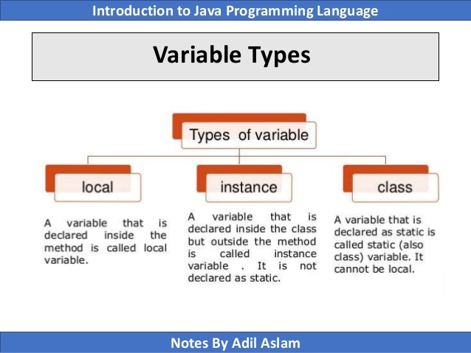 What is Variable? Variable is a place holder where you can store data (values, numbers, string etc.)

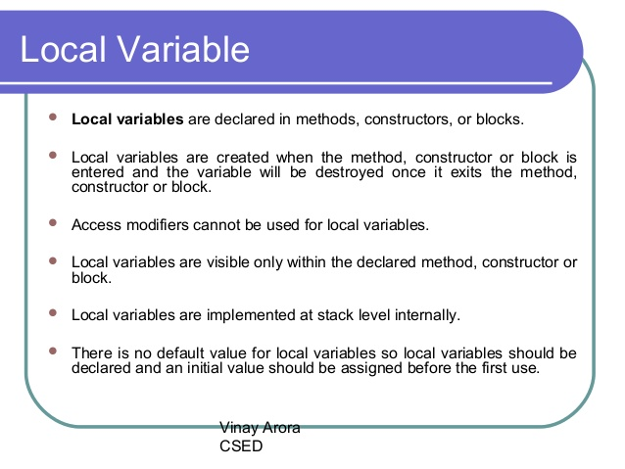

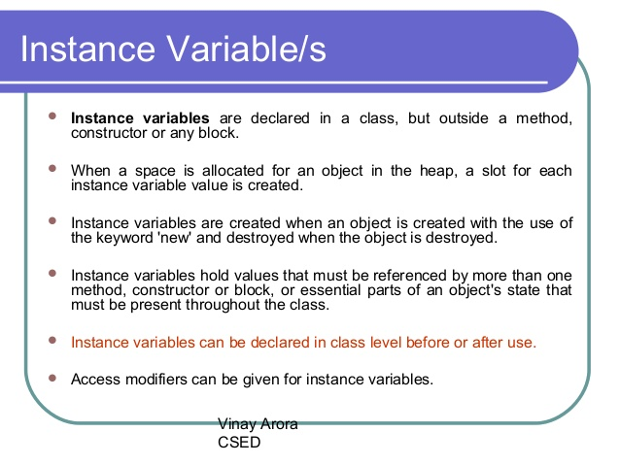

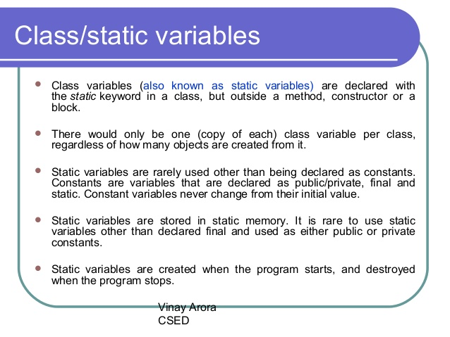

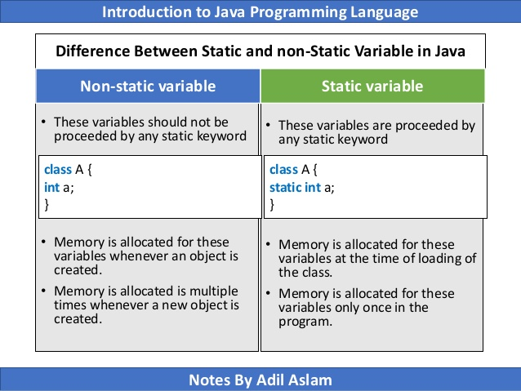

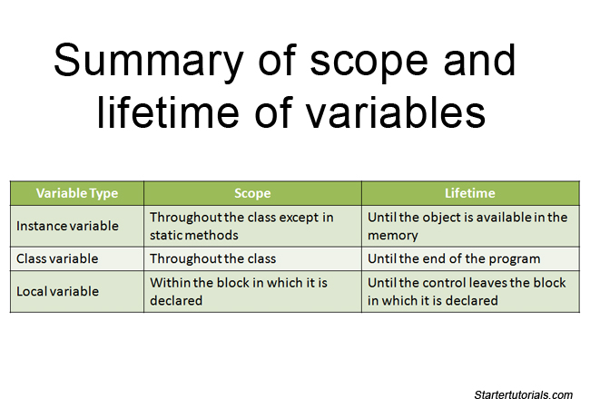

Method: Methods are consists of logics and arguments of an application.

There are two types of method.

1. Instance method
2. Static method.

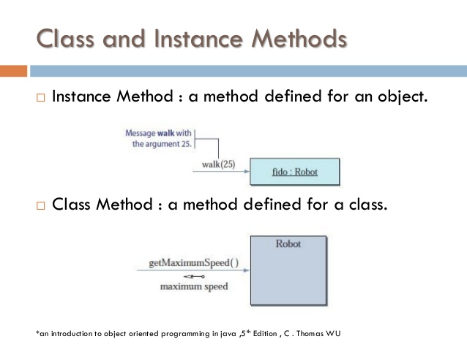

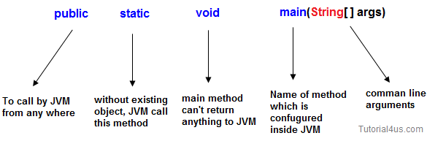

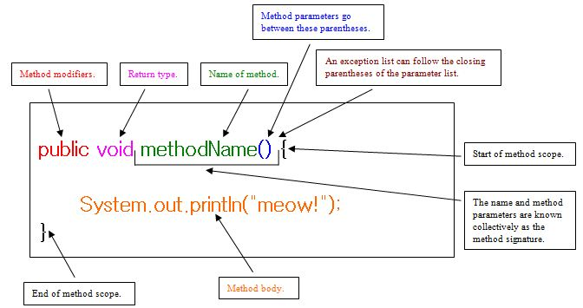

D

**Difference between non-static and static Method**

|  |  |  |
| --- | --- | --- |
|  | **Non-Static method** | **Static method** |
| 1 | These method never be preceded by static keyword Example:  **void** fun1()  {  ......  ......  } | These method always preceded by static keyword Example:  **static** **void** fun2()  {  ......  ......  } |
| 2 | Memory is allocated multiple time whenever method is calling. | Memory is allocated only once at the time of class loading. |
| 3 | It is specific to an object so that these are also known as instance method. | These are common to every object so that it is also known as member method or class method. |
| 4 | These methods always access with object reference Syntax:  **Objref.methodname();** | These property always access with class reference Syntax:  **className.methodname();** |
| 5 | If any method wants to be execute multiple time that can be declare as non static. | If any method wants to be execute only once in the program that can be declare as static . |

**Note:**In some cases static methods not only can access with class reference but also can access with object reference

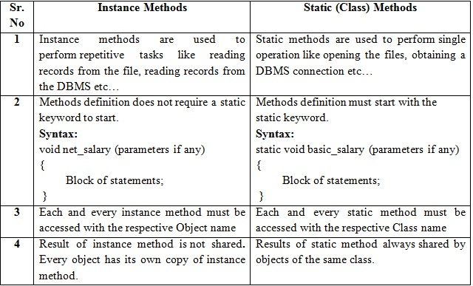

### Scope of method

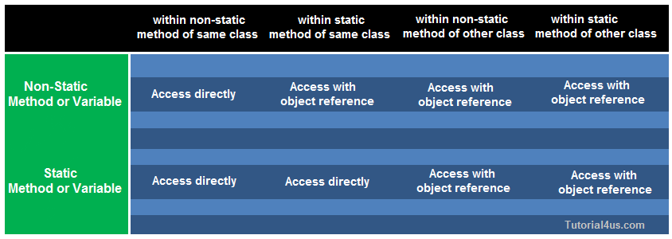

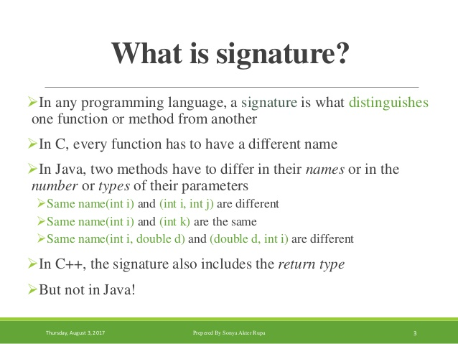

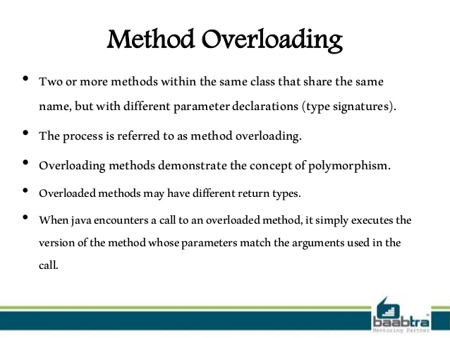

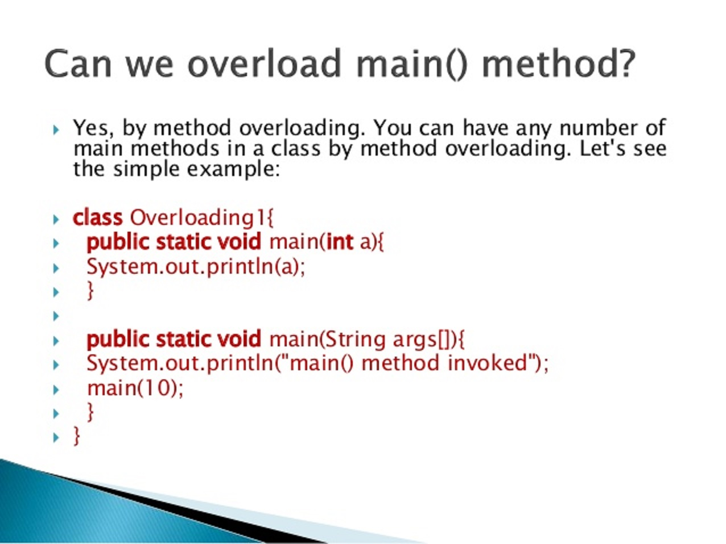

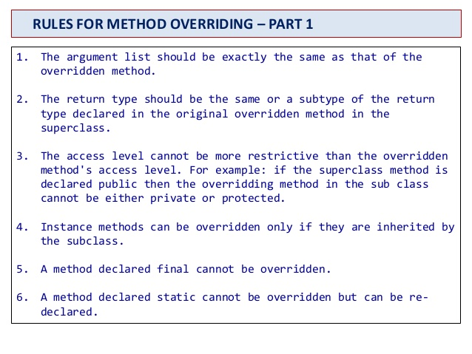

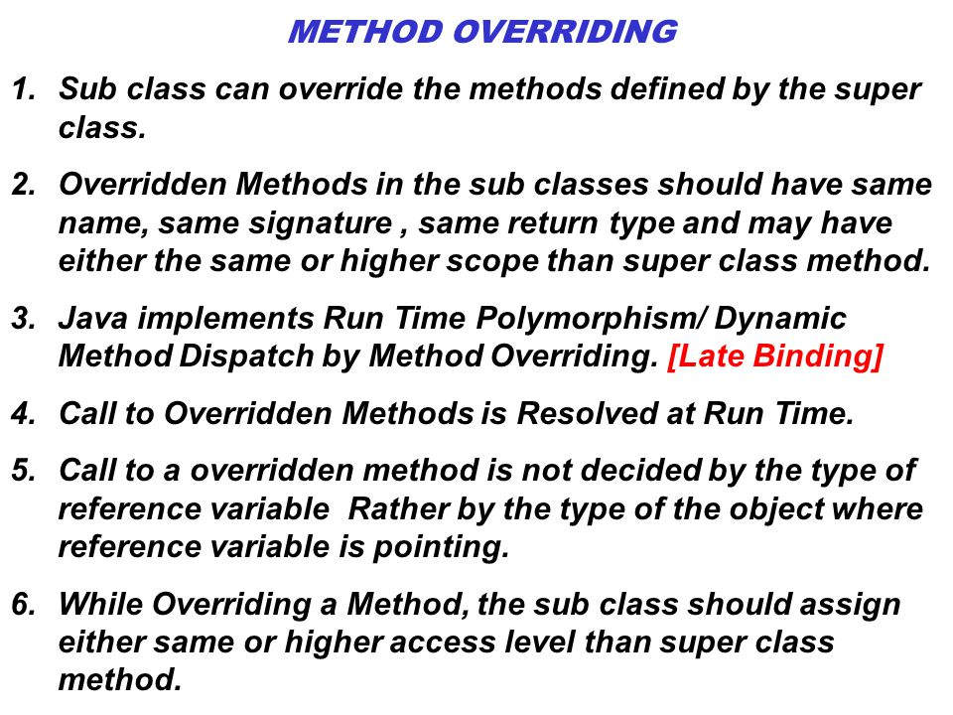

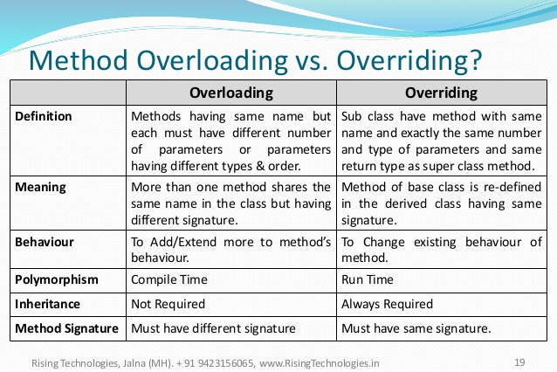

#### MODIFIER

What is modifier: There are two types of modifiers in java: access modifiers and **non**-access

Modifiers. The access modifiers in java specifies accessibility (scope) of a data member, method, constructor or class.

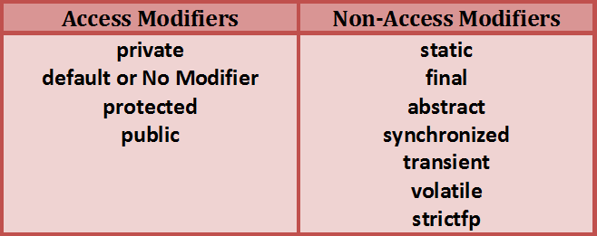

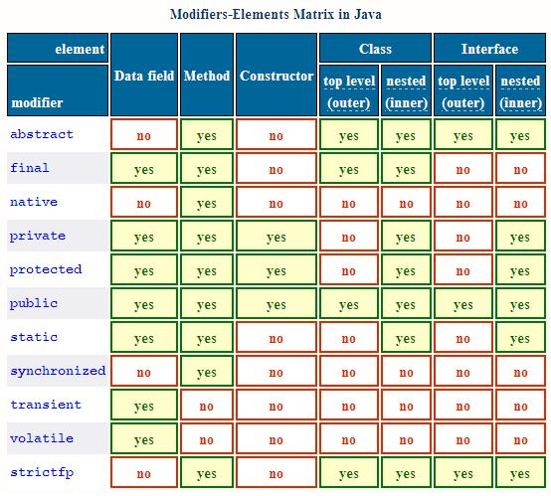

What is access modifier: **Java** provides a number of **access modifiers** to set **access** levels for classes, variables, methods, and constructors. The four **access** levels are

